[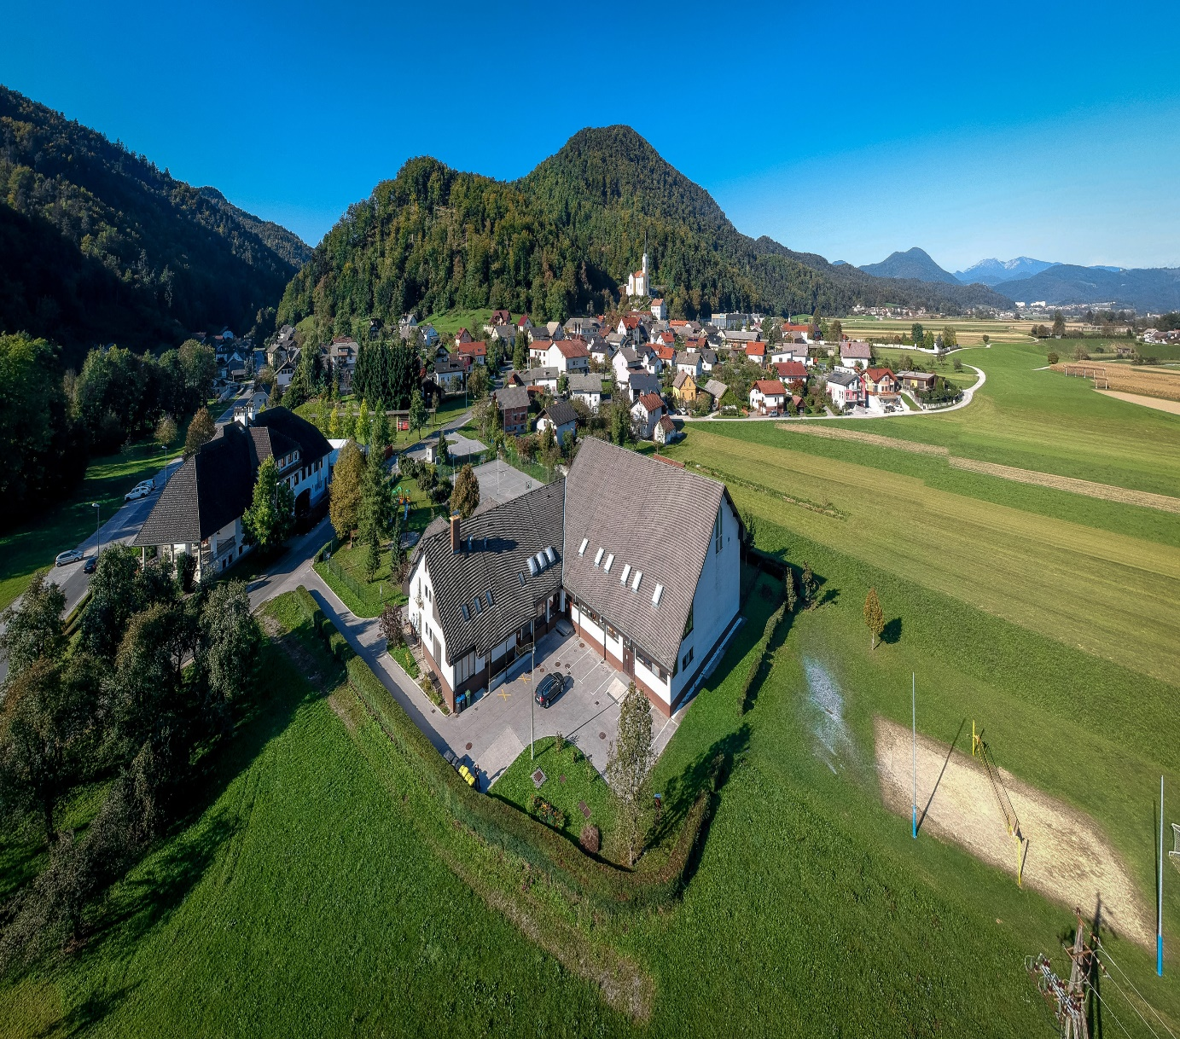](https://os-preska.si/wp-content/uploads/2018/10/OŠ_Preska_in_podružnici_-3-of-42-1.jpg)